**Setup git in your machine**

1. Download and install git (<https://git-scm.com/download/win>)

2. Set configurations

$ git config --global user.name "John Doe"

$ git config --global user.email johndoe@example.com

git config –list

Unset configuration if wanted

git config --global --unset-all user.name

3. Create a repository manually on GitHub

3. Move to the folder you want to make a repository. Use the following command to initialize the folder as a git repository. Create a new repository on the command line

git init

git add README.md

git commit -m "first commit"

git remote add origin https://github.com/kinathru/IdeaRestDemo05.git

git push -u origin master

**Creating a New Branch from Idea and Pushing it to GitHub**

Create a new branch

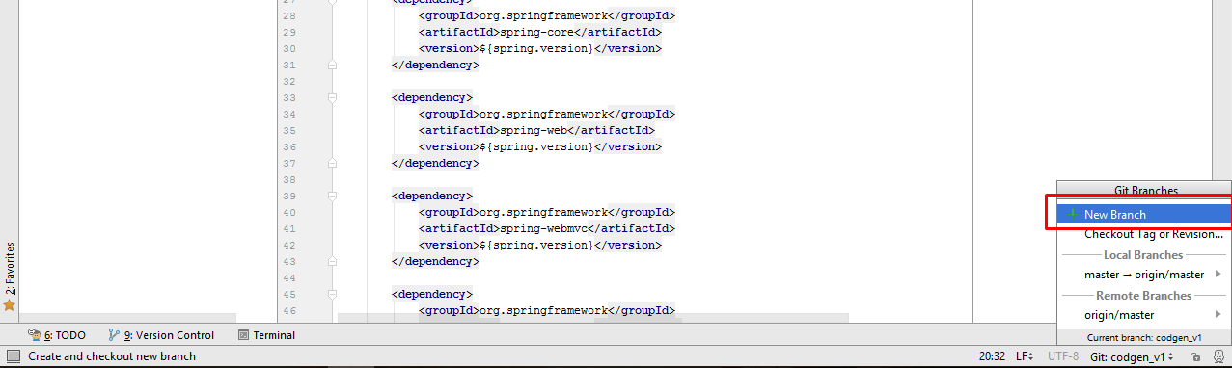

Use the following commands to push.

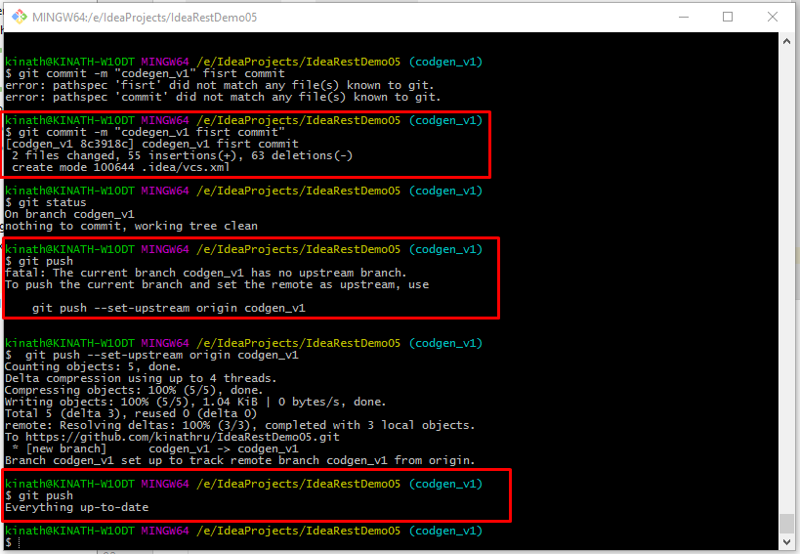

Branches will be appeared in the GitHub as following.

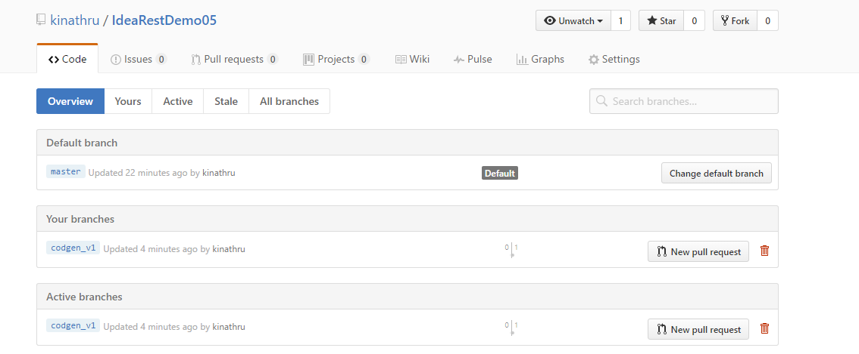

**FAQ**

1. **Remove directory from remote repository after adding them to .gitignore?** I committed and pushed some directory to github. After that, I altered the .gitignore file adding a directory that should be ignored. Everything works fine, but the (now ignored) directory stays on github. How do I delete that directory from github and the repository history?

**Answer:** The rules in your .gitignore file only apply to untracked files. Since the files under that directory were already committed in your repository, you have to unstage them, create a commit, and push that to GitHub:

git rm -r --cached some-directory

git commit -m 'Remove the now ignored directory "some-directory"'

git push origin master